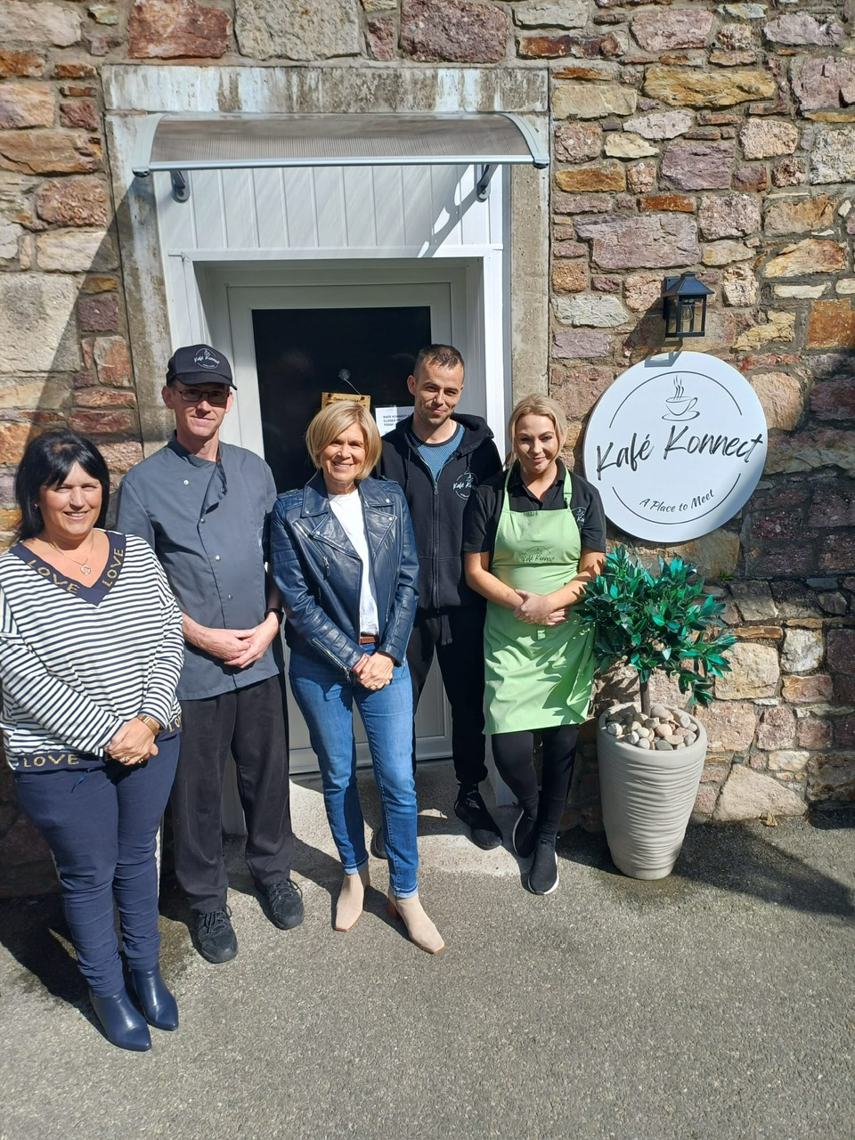

Kafe Konnect Celebrates One Year of Empowering Change

Monday 19th February marks a significant milestone for Kafe Konnect, the pioneering social enterprise established by the Cornmarket Project in County Wexford. One year ago, on Monday, February 20th, 2023, our doors swung open, welcoming the community to a café experience unlike any other. As we celebrate our first anniversary, we reflect on a year filled with triumphs, transformations, and tremendous growth.

Kafe Konnect isn't just a café; it's a beacon of hope, opportunity, and second chances. As part of Wexford Local Development and the Cornmarket Project, we've been able to provide training and employment to twelve individuals who had previously been involved with the Probation Service as a consequence of being caught up in the criminal justice system. These individuals, often facing significant barriers to traditional employment, have found a welcoming home at Kafe Konnect, where they're not just employees, but valued members of our family. One of the most remarkable aspects of our journey has been witnessing the incredible transformations of our team members. Many of those who work at Kafe Konnect have overcome the grips of addiction, reclaiming their lives, and embracing a future filled with promise and purpose. Their stories of resilience and hope inspire us every day and serve as a testament to the power of opportunity and support.

In our first year of operation, Kafe Konnect has exceeded all expectations. Not only have we provided meaningful employment and training, but we've also become a thriving hub of community engagement and social impact. And the impact doesn't stop within our walls; already, five of our team members have secured employment in the broader hospitality industry, paving the way for even more individuals to find success and stability.

On this special occasion, we extend our deepest gratitude to our loyal customers, whose continuing support has fuelled our success. Whether you've stopped in for a cup of coffee, shared a meal with friends, or simply spread the word about our mission, you've played a vital role in making Kafe Konnect the outstanding success it has become. And we couldn’t have achieved such success without the dedication of our superb Kafe Konnect team.

As we look ahead to the future, we are filled with excitement and optimism. With your continued support, Kafe Konnect will continue to be a force for positive change, creating opportunities, fostering community connection, and empowering individuals to reach their fullest potential.

Thank you for standing with us on this incredible journey. www.kafekonnect.ie