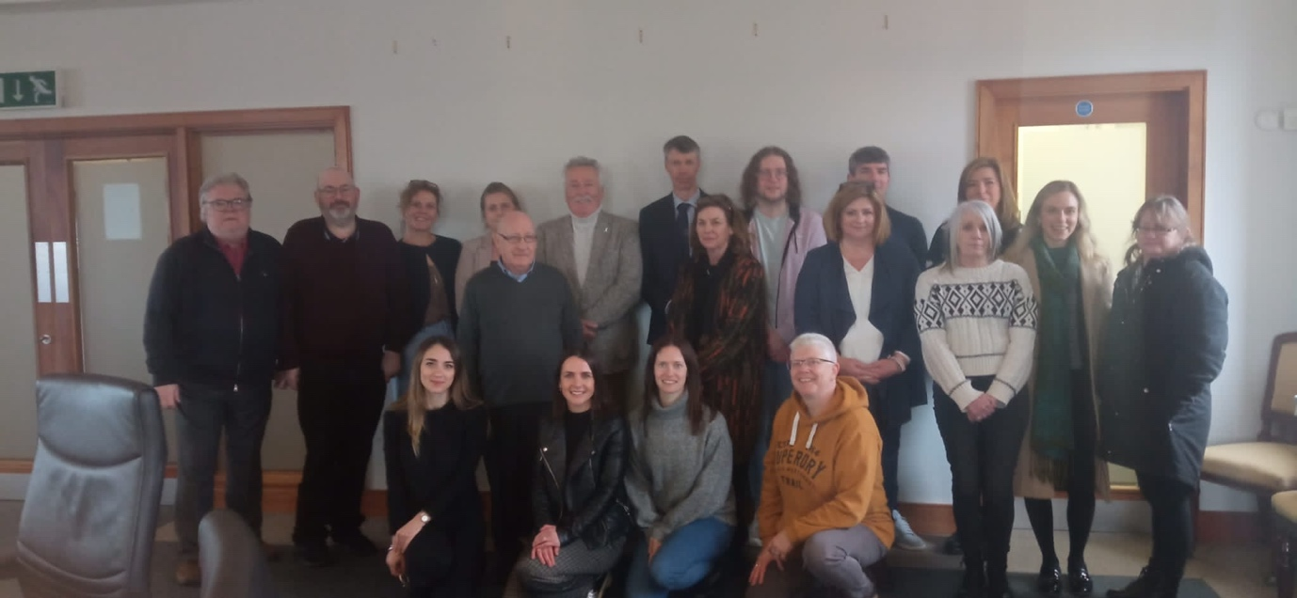

The Cornmarket Project in County Wexford recently had the privilege of hosting a transformative training and professional development event centered around the promotion and delivery of Restorative Justice. On February 13th and 14th, staff from the Probation Service, An Garda Siochana, and The Cornmarket Project, involved in delivering restorative justice across County Wexford, came together for a comprehensive two-day training event organised by Wexford Restorative Justice Services. This gathering wasn't just training, it was a collaborative effort aimed at strengthening interagency partnerships and enhancing our collective understanding of Restorative Justice principles.

The event featured sessions led by experienced trainers in the field. Professor Tim Chapman provided invaluable insights into navigating the intricacies of complex Restorative Justice cases, offering practical strategies for effective resolution. Additionally, Paul Delaney explored the crucial intersection of Restorative Justice and Trauma Informed Care, shedding light on how we can better support individuals affected by trauma within the criminal justice system.

Throughout the two days, attendees were immersed in a dynamic learning environment where knowledge was shared, perspectives were broadened, and connections were forged. The collaborative nature of the event fostered meaningful discussions, encouraging participants to explore new ideas and approaches to Restorative Justice practice. Events like these are invaluable for staff seeking to enhance their skills and deepen their understanding of Restorative Justice. Moreover, by coming together in this way, we not only invest in our own professional growth but also reaffirm our commitment to promoting healing, accountability, and reconciliation within our communities.

As we reflect on the success of this training event, we are reminded of the profound impact that interagency partnership working can have on the advancement of Restorative Justice initiatives. By leveraging our collective expertise and resources, we can continue to drive positive change and create a more just and compassionate society for all. We extend our thanks to all the participants for their dedication and enthusiasm. Together, we are building a brighter future rooted in the principles of restorative justice.

Paul Delaney, Coordinator of the Cornmarket Project, Wexford